### Table of Contents

1. Introduction………………………………………………………………1
2. System Architecture
   1. Introduction………………………………………….…………..4
   2. Module Division…………………………………………………6
3. System Design
   1. Requirement table……………………………………………….8
   2. Use Case…………………………………………………………9
   3. Sequence Diagram……………………………………………….10
   4. Activity Diagram………………………………………………...11
   5. E R Diagram…………………………………………………….14
4. Software and Hardware Requirements………………………..………….15
5. Software Implementation………………………………………………....16
6. Results………………………………………………………….…………20
7. Conclusion……………………………………………………………......36
8. References…………………………………………………………………37

**CHAPTER 1**

**INTRODUCTION**

**Introduction to Online Railway Reservation System**

The system is basically concerned with reservation and cancellation of railway ticket to the passenger. It is quite difficult to handle such a vast railway system. By computerizing network, it becomes possible to overcome limitations and make system operations more efficient.

By computerizing it user are required to register on the server for getting access to the database, thereby each user has individual accounts where the customer can view account details. The account contains comprehensive information about access history, past reservations, cancellation, enquire about train and train schedules, seat availability and can make reservations. Messages are send on successful payments, cancellation of tickets and on late arrival of train. Seasonal offers are updated.

The main advantages are

* Searching of data is easy
* Accurate information
* Fast processing and modification
* Centralized management system

**CHAPTER 2**

**SOFTWARE ARCHITECTURE**

**System Architecture of Online Railway Reservation System**

The railway network is a very vast system to be handled manually. By computerizing the system it will be of great help to both passenger and the employees. The customer and administrator are the two parties which are allowed to have access to the database of the system and its information.

Figure 1. shows the architecture of online railway reservation system.

Figure. 1 System Architecture of online railway reservation system

The architecture of online railway reservation system basically consist of two main actors. They are shown as below.

* Administrator
* User

The description of these modules are given as below.

Administrator

The administrator deals with both train details and user details.It takes the user details and also maintains the database. It updates the train Routes and its timing. It can see the user and passenger details and even delete their account if necessary.

The system security is maintained by the administrator. The user cannot access without the authentication of the user. It can also overcome problems like data redundancy and concurrent updation.

Passenger

The passenger can reserve ticket, cancel, check the routes, view seat availability etc. the passenger initially has to register an account and enter the details. They can make payment and can also cancel the ticket when required.

Messages will be sent on late arrival of the train, successful payment and on cancellation of tickets. Seasonal offers are also provided while reservation.

The system architecture of online railway reservation system consists of five modules. They are shown as below.

1. Train
2. Search
3. Reservation
   1. Ticket reservation
   2. Food reservation
4. Payment
5. Cancelation

Their description is given as below.

**Module Division**

1. TRAIN

The module train includes insertion of train details into a table. Train schedules are updated based up on the arrival of train. This module is the most important module of this project. Fares on different types of trains are updated.

1. SEARCH

The Search module searches the train based on source, destination and date. Train available on favourable date are selected are used for further processing.

1. RESERVATION

The Reservation module deals with two parts. They are given as follows.

3.1. Ticket Reservation: The reservation of favourable train. It deals with selection of favourable seats, number of seats and booking it with the user details.

3.2. Food Reservation: The food module deals with the selection of food while travelling. The user are provided with the food menu. The user can select their favourable food from the menu and pay them during reservation.

Messages are provided on successful reservation of tickets and food.

1. PAYEMENT

The payment module deals with the payment of the tickets reserved and the food ordered. The user can pay these online with the help of a credit card or debit card.

1. CANCELATION

The cancelation module deals with the cancelation of ticket and food ordered by the user and refunding the payment back to the user. Messages are provided to the user after successful cancelation.

**CHAPTER 3**

**SYSTEM DESIGN**

**OVERVIEW**

System design is the process of defining the [architecture](https://en.wikipedia.org/wiki/Systems_architecture), modules, interfaces, and [data](https://en.wikipedia.org/wiki/Data) for a [system](https://en.wikipedia.org/wiki/System) to satisfy specified [requirements](https://en.wikipedia.org/wiki/Requirement). It is a process to transform user requirements into some suitable form, which helps the programmer in software coding and implementation.

For assessing user requirements, an SRS (Software Requirement Specification) document is created whereas for coding and implementation, there is a need of more specific and detailed requirements in software terms. The output of this process can directly be used into implementation in programming languages. Systems design could be seen as the application of [systems theory](https://en.wikipedia.org/wiki/Systems_theory) to [product development](https://en.wikipedia.org/wiki/Product_development).

The system design of Online Railway reservation system includes the following

* 1. Requirement table
  2. Use case diagram
  3. Sequence diagram
  4. Activity diagram
  5. E R Diagram

**3.1 Requirement table**

The requirement tables are prepared for the analytic use of benchmark IO accounts. This table provides a brief overview of stake holder requirement and features f this project. Table 1 shows the requirement table of the project online railway reservation system. There are two types of requirements- Stake holder Requirement and feature.

[Stakeholder requirements](http://sebokwiki.org/wiki/Stakeholder_Requirement_(glossary)) represent the views of those at the business or enterprise operations level that the [users](http://sebokwiki.org/wiki/User_(glossary)), [acquirers](http://sebokwiki.org/wiki/Acquirer_(glossary)), [customers](http://sebokwiki.org/wiki/Customer_(glossary)), and other [stakeholders](http://sebokwiki.org/wiki/Stakeholder_(glossary)) as they relate to the problem, as a set of requirements for a solution that can provide the services needed by the stakeholders in a defined environment. Using enterprise-level life cycle concepts as guidance, stakeholders are led through a structured process to elicit stakeholder needs.

Stakeholder needs are transformed into a defined set of Stakeholder Requirements, which may be documented in the form of a model, a document containing textual requirement statements or both.

Features represent the additional requirements added to the application to make it more efficient.

Table 1. Requirement table

|  |  |  |  |
| --- | --- | --- | --- |
| **RNO** | **DESCRIPTION** | **REQUIREMENT TYPE** | **PRIORITY** |
| 1 | The system should maintain details like train schedule,ticket availability | STRQ1 | HIGH |
| 2 | Authentication code | FEAT1 | HIGH |
| 3 | Show list of train and choose the source and destination | STRQ2 | HIGH |
| 4 | Home page advertisement on offers | STRQ3 | MEDIUM |
| 5 | Seat number and type | STRQ4 | HIGH |
| 6 | Reserve seat and make payment | STRQ5 | HIGH |
| 7 | Provide booking of food while reservation | STRQ6 | HIGH |
| 8 | Display food menu,cost and offers | STRQ7 | MEDIUM |
| 9 | Messages provided after successful booking | STRQ8 | HIGH |
| 10 | Messages on offers provided | STRQ9 | MEDIUM |
| 11 | Cancellation done online | FEAT 2 | HIGH |
| 12 | Error handling on concurrency access of passengers | FEAT3 | HIGH |

**3.2 Usecase diagram**

Use case diagram is the simple representation of the user’s interaction with the system that shows the relationship between the user and the different usecases in which the user is involved. Use case diagram can identify different types of users of a system and the different usecases. Figure 2 shows use case of online railway reservation system.



Figure 2. Use Case Diagram

**3.3 Sequence diagram**

It is the construct of a message sequence chart. A sequence diagram shows object interactions arranged in time sequence. It depicts the objects and the classes involved in the scenario and the sequence of messages exchanged between the objects needed to carry out the functionality of the scenario.

Figure 3 represent the sequence diagram of online railway reservation system.



Figure. 3 sequence diagram

**3.4 Activity diagram**

Activity diagram is another important diagram in uml to describe dynamic aspects of the system. Activity diagram is basically a flow chart to represent the flow from one activity to another activity. The activity can be described as an operation of the system. So the control flow is drawn from one operation to another.



Figure 5. Login activity

In figure.5 the activity diagram shows the process of logging into a page, from entering your username and password, to successfully logging into the system. If login id and password is valid it goes to next page else it goes to home page.



Figure. 6 search activity

Figure 6. Depicts the activity that occurs after logging in to the log in page. The user is provided with a search page where user can search the train details by entering the source and destination. When the search is successful, the user enters the next page.



Figure. 7 reservation/cancellation activity

Figure 7. depicts the next activity after searching the train.The next activity discribes the reservation and cacellation action.The user can either reserve the ticket or cancel the ticket.Reservation include checking the available seat and reserving the favorable seat.

Another activity is cancellation.The user can cancel the ticket by entering the required information.Message are send to the user’s phone number on sucessfully reservation and cancellation.

**3.5 E R Diagram**

ER-Diagram is a visual representation of data that describes how data is related to each other.An Entity can be any object, place, person or class. In E-R Diagram, an entity is represented using rectangles. Weak entity is an entity that depends on another entity. Weak entity doesn't have key attribute of their own. Double rectangle represents weak entity.An Attribute describes a property or characteristic of an entity. An attribute is represented using eclipse.

The figure 8. depict E R Diagram for the online railway reservation system .

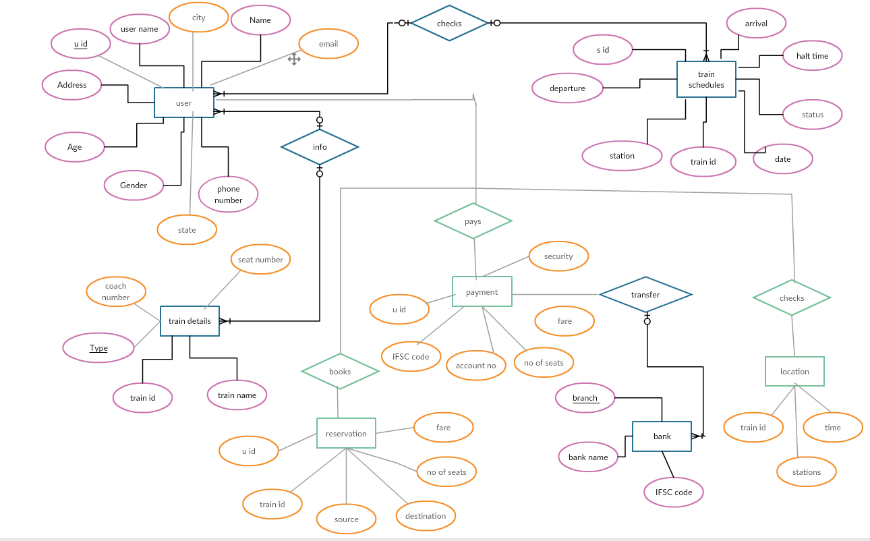

Figure 8.E R Diagram

**CHAPTER 4**

**HARDWARE AND SOFTWARE REQUIREMENT**

**SOFTWARE AND HARDWARE REQIUREMENTS**

HARWARE REQUIREMENTS:

1. Operating System: windows 8.1
2. Processor : Intel core I3
3. RAM: 4GB
4. HARD DISK: 8GB

SOFTWARE REQUIREMENTS:

1.Android Studio 2.3.1

2.Net Beans 8.1

3.Wamp Server 3.3.9

**CHAPTER 5**

**SOFTWARE IMPLEMENTATION**

The software basically deals with Online Railway Reservation System. The system consist of two veiw-user veiw and administrator veiw. User view is done in android studio and the administrator veiw is done in net beans. The database is basically stored in wamp server.

Android Studio is the official [integrated development environment](https://en.wikipedia.org/wiki/Integrated_development_environment) (IDE) for the [Android](https://en.wikipedia.org/wiki/Android_(operating_system)) platform. Android Studio was in early access preview stage starting from version 0.1 in May 2013, then entered beta stage starting from version 0.8 which was released in June 2014. It is a [Gradle](https://en.wikipedia.org/wiki/Gradle)-based build support. It is Android-specific [refactoring](https://en.wikipedia.org/wiki/Code_refactoring) and quick fixes. It contains [Lint](https://en.wikipedia.org/wiki/Lint_(software)) tools to catch performance, usability, version compatibility and other problems. It is a [ProGuard](https://en.wikipedia.org/wiki/ProGuard_(software)) integration and also contain app-signing capabilities. It has Template-based wizards to create common Android designs and components. It contain XML codes for designing and java code for coding. It support for building [Android Wear](https://en.wikipedia.org/wiki/Android_Wear) apps.

Example of android code to print ‘hello world’ is as follows.

XML CODE:

<**android.support.constraint.ConstraintLayoutxmlns:android="http://schemas.android.com/apk/res/android"  
xmlns:app="http://schemas.android.com/apk/res-auto"  
xmlns:tools="http://schemas.android.com/tools"  
android:layout_width="match_parent"  
android:layout_height="match_parent"  
tools:context="com.example.lenovo.app123.MainActivity"**>  
  
<**TextView  
android:layout_width="wrap_content"  
android:layout_height="wrap_content"  
android:text="Hello World!"  
app:layout_constraintBottom_toBottomOf="parent"  
app:layout_constraintLeft_toLeftOf="parent"  
app:layout_constraintRight_toRightOf="parent"  
app:layout_constraintTop_toTopOf="parent"** />  
  
</**android.support.constraint.ConstraintLayout**>

JAVA CODE:

**package**com.example.lenovo.app123;  
  
**import** android.support.v7.app.AppCompatActivity;  
**import** android.os.Bundle;  
  
**public class** MainActivity**extends**AppCompatActivity {  
  
@Override  
**protected void** onCreate(Bundle savedInstanceState) {  
**super**.onCreate(savedInstanceState);  
setContentView(R.layout.***activity_main***);  
 }  
}

Android studio contains Android Virtual Device (Emulator) to run and debug apps.

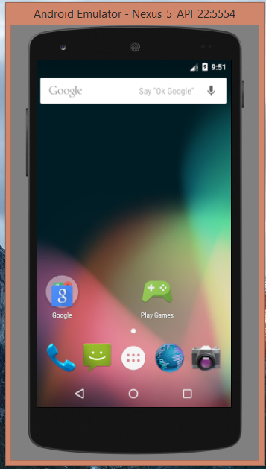 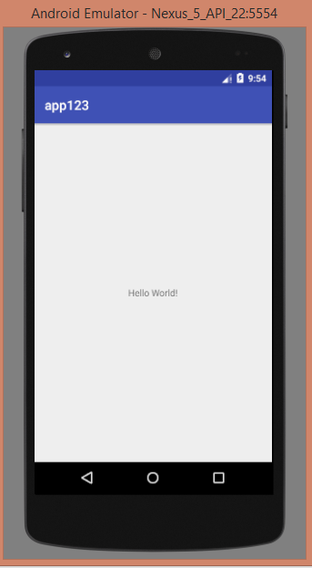

In this project, the user is provided with the the register page. The new user can register into the application for further user. Once registerd,the user can simply log in to the application.After loging in, the user is provided with the search page,where user can search the train by entering the source, destination and journey date. The user can choose their favorable seats and book their ticket. The user are also provided with an option to book food while travel. Messages on successful payement and cancellation are provided.

The java code for registration is shown below.

import android.content.Intent;

import android.os.Bundle;

import android.support.v7.app.AppCompatActivity;

import android.util.Log;

import android.view.View;

import android.widget.AdapterView;

import android.widget.ArrayAdapter;

import android.widget.Button;

import android.widget.EditText;

import android.widget.RadioGroup;

import android.widget.Spinner;

import android.widget.Toast;

import org.apache.http.NameValuePair;

import org.apache.http.message.BasicNameValuePair;

import org.json.JSONArray;

import org.json.JSONObject;

import java.util.ArrayList;

import java.util.List;

public class Reg extends AppCompatActivity implements AdapterView.OnItemSelectedListener {

EditText name,password,cp,age,email,address,pin,pn;

RadioGroup gender;

Spinner city,state;

Button submit;

String name1,password1,cp1,age1,email1,address1,city1,state1,pin1,pn1;

String gender1;

ipaddress ipp=new ipaddress();

String myip=ipp.ip;

@Override

protected void onCreate(Bundle savedInstanceState) {

super.onCreate(savedInstanceState);

setContentView(R.layout.activity_reg);

name = (EditText) findViewById(R.id.name);

password = (EditText) findViewById(R.id.password);

age = (EditText) findViewById(R.id.age);

gender = (RadioGroup) findViewById(R.id.gender);

email = (EditText) findViewById(R.id.email);

address = (EditText) findViewById(R.id.address);

city = (Spinner) findViewById(R.id.city);

state = (Spinner) findViewById(R.id.state);

pin = (EditText) findViewById(R.id.pin);

pn = (EditText) findViewById(R.id.pn);

submit = (Button) findViewById(R.id.submit);

city.setOnItemSelectedListener(this);

List<String> categories = new ArrayList<String>();

categories.add("--select an option--");

categories.add("Ernakulam");

categories.add("Thrissur");

categories.add("Kozhikode");

categories.add("Kottayam");

categories.add("Alapuzha");

ArrayAdapter dataAdapter = new ArrayAdapter(this, android.R.layout.simple_spinner_item, categories); dataAdapter.setDropDownViewResource(android.R.layout.simple_spinner_dropdown_item);

city.setAdapter(dataAdapter);

state.setOnItemSelectedListener(this);

List<String> categories1 = new ArrayList<String>();

categories1.add("--select an option--");

categories1.add("Kerala");

ArrayAdapter dataAdapter1 = new ArrayAdapter(this, android.R.layout.simple_spinner_item, categories1); dataAdapter1.setDropDownViewResource(android.R.layout.simple_spinner_dropdown_item);

state.setAdapter(dataAdapter1);

submit.setOnClickListener(new View.OnClickListener() {

@Override

public void onClick(View view) {

password1=password.getText().toString();

name1=name.getText().toString();

age1=age.getText().toString();

int selectedId = gender.getCheckedRadioButtonId();

if(selectedId == R.id.female) {

gender1 = "Female";

}

else

{

gender1 = "Male";

}

email1=email.getText().toString();

address1=address.getText().toString();

city1=city.getSelectedItem().toString();

state1=state.getSelectedItem().toString();

pin1=pin.getText().toString();

pn1=pn.getText().toString();

if(name1.equals("")&&password1.equals("")&&age1.equals("")&&gender1.equals("")&&email1.equals("")&&address1.equals("")&&city1.equals("")&&state1.equals("")&&pin1.equals("")&&pn1.equals(""))

{

Toast.makeText(Reg.this, "Enter Details Correctly",Toast.LENGTH_LONG).show();

}

else

{

try

{

WebServer loginweb=new WebServer();

Log.e("inside", "try");

List<NameValuePair> loginlist = new ArrayList<NameValuePair>(10);

loginlist.add(new BasicNameValuePair("name1", name1));

loginlist.add(new BasicNameValuePair("password1", password1));

loginlist.add(new BasicNameValuePair("age1", age1));

loginlist.add(new BasicNameValuePair("gender1", gender1));

loginlist.add(new BasicNameValuePair("email1", email1));

loginlist.add(new BasicNameValuePair("address1", address1));

loginlist.add(new BasicNameValuePair("city1", city1));

loginlist.add(new BasicNameValuePair("state1", state1));

loginlist.add(new BasicNameValuePair("pin1", pin1));

loginlist.add(new BasicNameValuePair("pn1", pn1));

JSONArray ja=loginweb.doPost(loginlist, myip+"/reg.jsp");

if(ja!=null)

{

JSONObject jo = (JSONObject) ja.get(0);

if(jo.getString("resp").equals("success"))

Toast.makeText(Reg.this, "Success", Toast.LENGTH_LONG).show();

Intent intent=new Intent(Reg.this,Login1.class);

startActivity(intent);

}

}

else

{ Toast.makeText(Reg.this, "Connection Error",

Toast.LENGTH_SHORT).show();

}

}

catch (Exception e) {

e.printStackTrace();

}

}

}

});

}

@Override

public void onItemSelected(AdapterView<?> adapterView, View view, int i, long l) {

}

@Override

public void onNothingSelected(AdapterView<?> adapterView) {

}

}

\

NetBeans is a [software development](https://en.wikipedia.org/wiki/Software_development) [platform](https://en.wikipedia.org/wiki/Platform_(computing)) written in [Java](https://en.wikipedia.org/wiki/Java_(programming_language)). The NetBeans Platform allows applications to be developed from a set of modular [software components](https://en.wikipedia.org/wiki/Software_component) called *modules*. Applications based on the NetBeans Platform, including the NetBeans [integrated development environment](https://en.wikipedia.org/wiki/Integrated_development_environment) (IDE), can be extended by [third party developers](https://en.wikipedia.org/wiki/Third_party_developer). The NetBeans IDE is primarily intended for development in Java, but also supports other languages, in particular [PHP](https://en.wikipedia.org/wiki/PHP), [C](https://en.wikipedia.org/wiki/C_(programming_language))/[C++](https://en.wikipedia.org/wiki/C%2B%2B) and [HTML5](https://en.wikipedia.org/wiki/HTML5). NetBeans is [cross-platform](https://en.wikipedia.org/wiki/Cross-platform) and runs on [Microsoft Windows](https://en.wikipedia.org/wiki/Microsoft_Windows), [Mac OS X](https://en.wikipedia.org/wiki/Mac_OS_X), [Linux](https://en.wikipedia.org/wiki/Linux), [Solaris](https://en.wikipedia.org/wiki/Solaris_(operating_system)) and other platforms supporting a compatible [JVM](https://en.wikipedia.org/wiki/Java_Virtual_Machine).The NetBeans Team actively supports the product and seeks feature suggestions from the wider community. Every release is preceded by a time for Community testing and feedback.

Example of net beans code to print ‘HELLO WORLD’ is given as follows.

<html>

<head>

<title>SAMPLE</title>

<meta charset="UTF-8">

<meta name="viewport" content="width=device-width, initial-scale=1.0">

</head>

<body>

<div>HELLO WORLD</div>

</body>

</html>

The output of the above code is given as below. 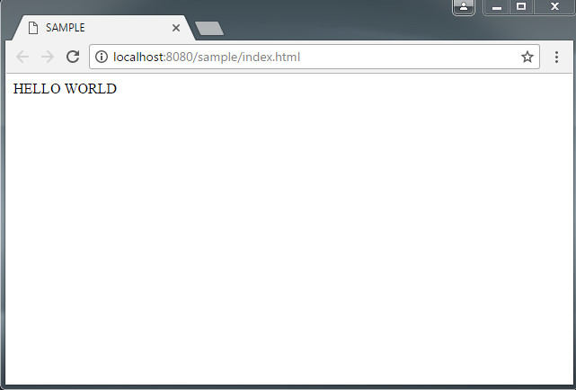

In this projet,which is done in netbeans , the admin logs into the administrator page with its login id and password.The administrator is provided with different features like veiwing the users who reserved for tickets.The administrator can also schedule the train or add the trains.The administrator can add options for the user while booking.

The other main component of this project is database, which is done in wamp server. The database include 7 tables. Each table contain its primary key and corresponding foriegn key.The different tables and its attributes are given as follows.

The database is stored in wamp server. The database consist of 8 tables. Each table performs its own functionalities.

1. REGISTER TABLE

The registration table stores the details of each user, ie the user name,pssword,age,gender,email,address,city,state,pin,phone number etc.This table assigns a unique id for each user.

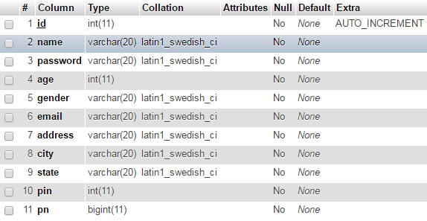

1. LOGIN TABLE

The login table hold the log of each user who logs in to the application. It also assigns a unique id to the each user loging into the application.

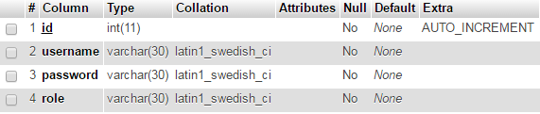

1. TRAIN LIST TABLE

The train list table maintains the details of each train,the name of train,its arrival time,prnno and the station each train covers.

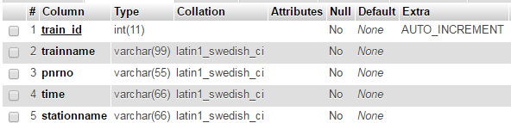

1. SEAT TABLE

The seat table maintains the seating details of each train,the seat type and price of each seat.

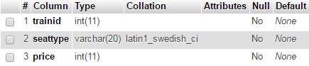

1. BOOKING TABLE

The booking table consist of the reservation details of each user. It includes user id, train id, seatno and amount to be paid.

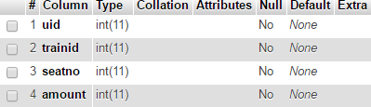

1. FOOD LIST

The food list table consist of the variety of food available while travelling. It include the category of food,name of food and price of each food item. The table assigns unique id for each food item.

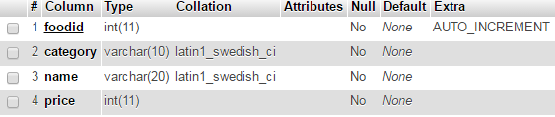

1. FOOD BOOKING

The food booking table consist of the detais of the users who have ordered the food.The table includes food id,user id,and the cost to be paid.

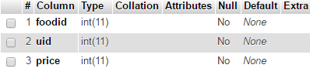

1. TOTAL PAYMENT

The total payment table consist of the final billing details of the user. It contain user id,ticket cost,food cost and the total cost for each user.

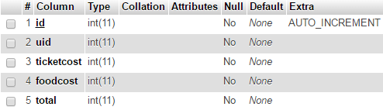

**CHAPTER 6**

**RESULT**

ADMINISTRATOR

The administrator is provided with home page where administrator can log in and do their performance. The administrator has a unique username and password.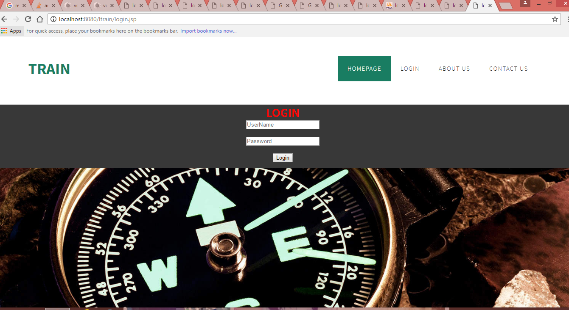

After the adminitrator log in to the administrators area,the administrator is led to the a homepage which provides the administrator various options like log out frm the account, add train list, veiw the users who have reservered ticket,add food menu,veiw users who ordered food and send message to user.

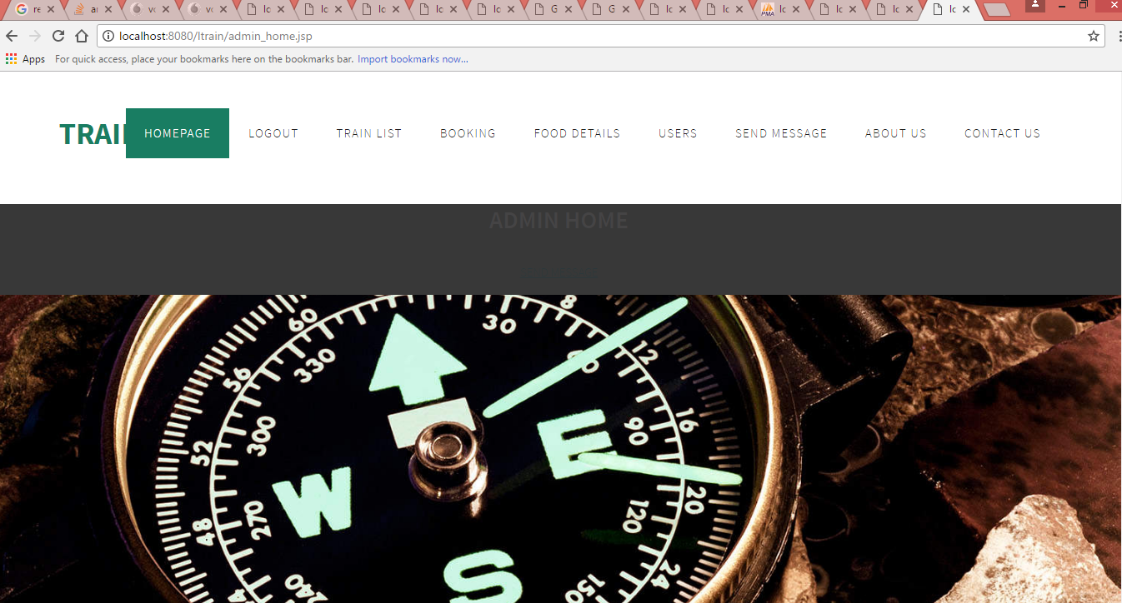

By clicking on tainlist,the administrator can add different trains and their schedules.

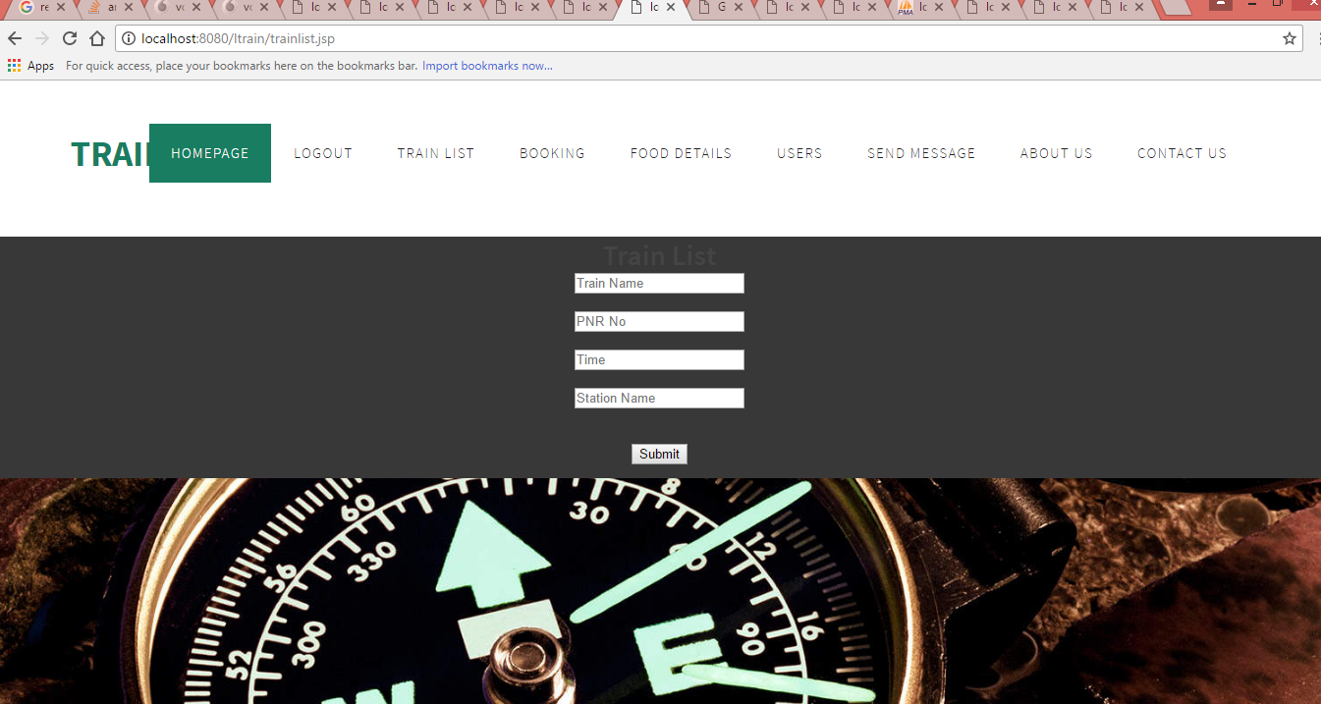

By clicking on the booking icon,the administrator can veiw the different users who have done booking.

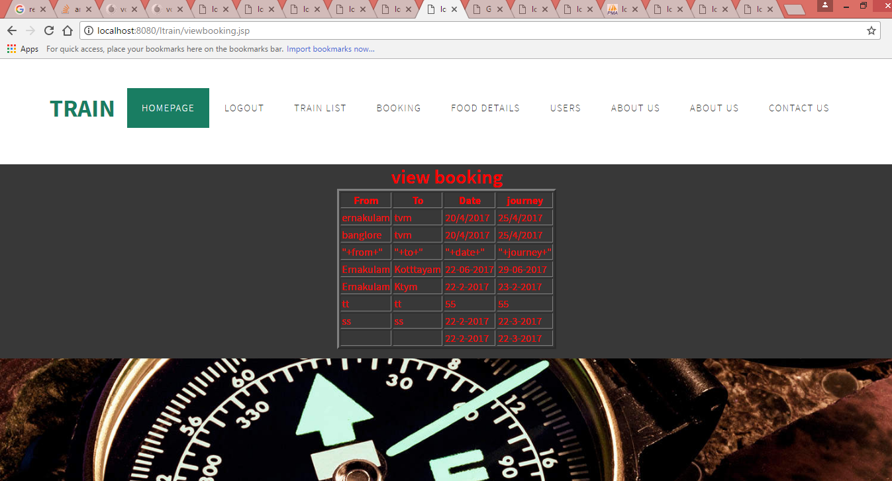

By clicking on food details, the administrator can add or delete food details into the food menu.

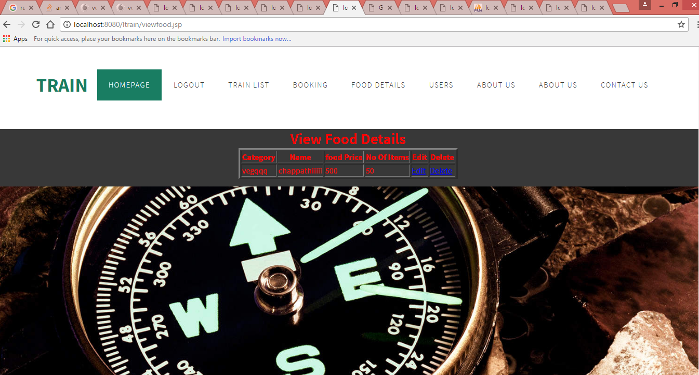

By clicking on the users, the administrator can veiw different user registered in the application.

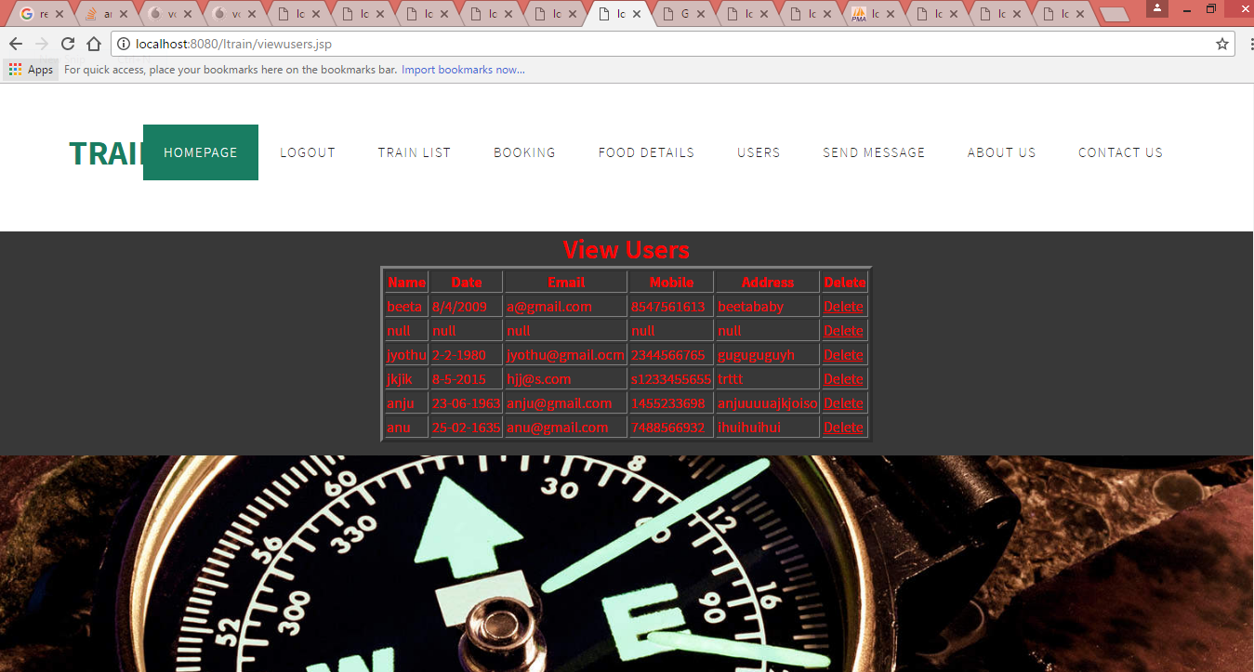

By clicking on seng message,the user can send messages to the user’s phone number.

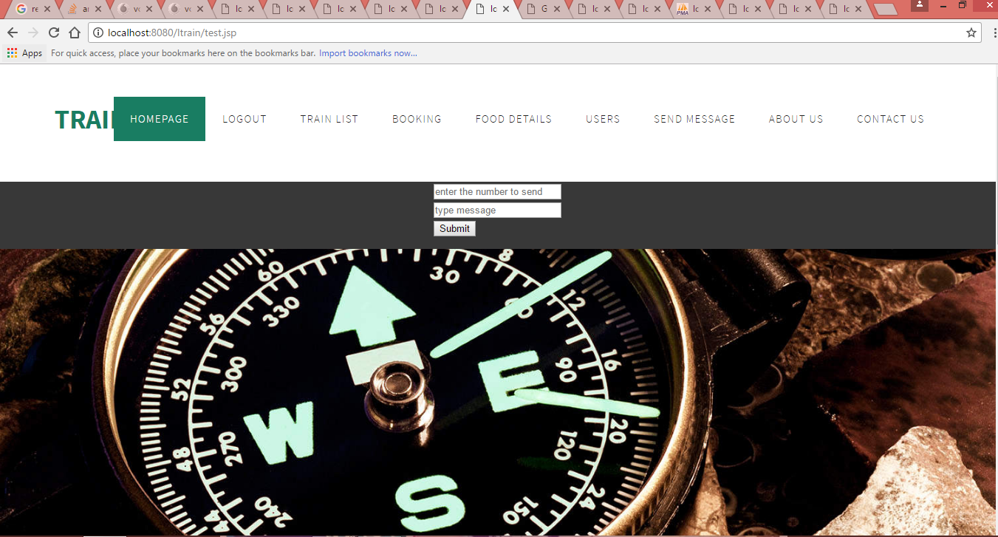

USER

The user is initially rovided with a log in page where the registerd user acn just log in to the application using username and password. The new user can click on register botton to register themselves.

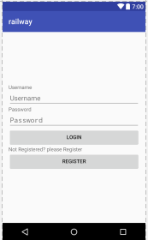

The registration page allows the user to fill the details and phone name,password,age,gender,address,city,state,pin number and phone number.

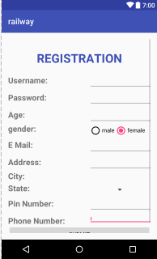

After registration,the user logs in to the application. After logging in to the application,the user is provided with a search page where user can search the train based on source,destination and journey date.

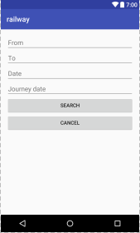

After entering the data in search page,the user is displayed with result of train that passes through the source and destination .

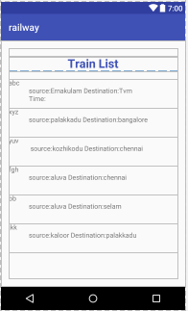

After selecting the favorable train,the user moves to the reservation page where user acn reserve their favorable train. In the same page,the user is provided with a provision to order food while travelling.

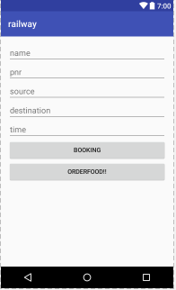

User can boomk food based up on the category they wish to order-veg or non veg.

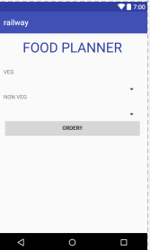

After ordering the food,the user can pay the cost of the ticket and cost of food together.

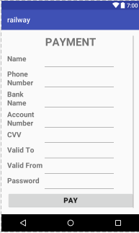

**CONCLUSION**

The main aim of developing Railway Reservation system is to provide all information that is required by the users.User friendliness is a must that is the user must get the details without complicated searching procedures.Other important requirement are data secuirity,extensiblity and maintainablity. Messages provided on sucessful reservation and cancellation made this system more user friendly.All these features are included in this application.

This project greatly helped in understanding the various phases of android development and an exposure to a new developer platform on Android Studio,Net Beans and Wamp Server.

After the successfull implementation on Railway Reservation System,it will help in management for managing task efficiently.

While some of the features have implemented in this project, some features are left , which we would like to implement as future enhancement. Tracking of each train is one of the feature added to it. User is able to track their train and messages are provided on late arrival of train. Another feature that we would like to add on in future is that special offers on off season are provided to the user.

**REFERENCE**

[www.slideshare.com](http://www.slideshare.com)

[www.scribd.com](http://www.scribd.com)

[www.wikipedia.com](http://www.wikipedia.com)